VISVESVARAYA TECHNOLOGICAL UNIVERSITY
“JnanaSangama”, Belgaum -590014, Karnataka.

LAB REPORT On
DATA STRUCTURES (23CS3PCDST)
Submitted by
SHRIHARI VISWANATHAN (1BF24CS288)
in partial fulfillment for the award of the degree of
BACHELOR OF ENGINEERING
in
COMPUTER SCIENCE AND ENGINEERING

B.M.S. COLLEGE OF ENGINEERING
(Autonomous Institution under VTU)
BENGALURU-560019 August-December 2025
B. M. S. College of Engineering,
Bull Temple Road, Bangalore 560019
(Affiliated To Visvesvaraya Technological University, Belgaum) Department of Computer Science and Engineering

This is to certify that the Lab work entitled “DATA STRUCTURES” carried out by SHRIHARI VISWANATHAN (1BF24CS288), who is bonafide student of B. M. S. College of Engineering. It is in partial fulfillment for the award of Bachelor of Engineering in Computer Science and Engineering of the Visvesvaraya Technological University, Belgaum during the year 20252026. The Lab report has been approved as it satisfies the academic requirements in respect of Data structures Lab - (23CS3PCDST) work prescribed for the said degree.
Dr. Namratha M | Dr. Kavitha Sooda
Assistant Professor | Professor and Head
Department of CSE | Department of CSE
BMSCE, Bengaluru | BMSCE, Bengaluru
Index Sheet
Sl.  No. | Experiment Title | Page No.
1
2
3
4
5
6
7
8
9
10

Course outcomes:
CO1 | Apply the concept of linear and nonlinear data structures.
CO2 | Analyze data structure operations for a given problem
CO3 | Design and develop solutions using the operations of linear and nonlinear data structure for a given specification.
CO4 | Conduct practical experiments for demonstrating the operations of different data structures.
Lab program 1:
Write a program to simulate the working of stack using an array with the following: a) Push
- Pop
- Display
The program should print appropriate messages for stack overflow, stack underflow.
#include <stdio.h>
#define N 2
int stack[N];
int top = -1;
void push();
void pop();
void peek();

int main()
{
int i = 1;
while(i == 1){
printf("\n");
printf("\n");

printf("Operations for the stack:\n");
printf("1. Push\n");
printf("2. Pop\n");
printf("3. Peek\n");
printf("4. Exit\n");

int choice = 0;
printf("Enter choice: ");
scanf("%d", &choice);

switch(choice){
case 1: push();
break;

case 2: pop();
break;

case 3: peek();
break;

case 4: i = 0;
break;
}
}

}

void push(){
int value = 0;
printf("Integer to push: ");
scanf("%d", &value);

if (top == N - 1){
printf("Stack Overflow");
}

else{
top++;
stack[top] = value;

}
}

void pop(){
if (top == -1){
printf("Stack underflow");
}

else{
int item = stack[top];
printf("the item on the top was %d", item);
top--;

}
}

void peek(){

if (top == -1){
printf("Underflow");
}

else{
printf("Element: %d", stack[top]);
}
}

Output:
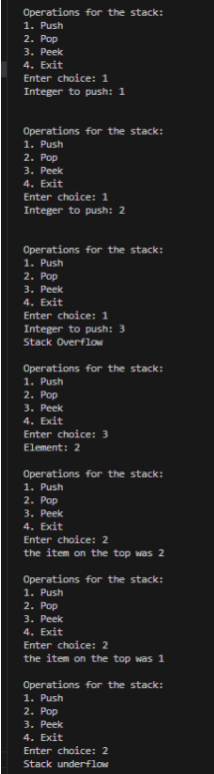

Lab Program 2:

WAP to convert a given valid parenthesized infix
arithmetic expression to postfix expression. The
expression consists of single character operands and the
binary operators + (plus),
- (minus), * (multiply) and /
(divide)

CODE:
#include<stdio.h>
#include<ctype.h>
#include<string.h>

#define MAX 100

void push(char c);
char pop();
char peek();
int associativity(char operator);
int precedence(char operator);
void infix_to_postfix(char infix[], char postfix[]);

char infix[MAX];
char postfix[MAX];
char stack[MAX];
int top = -1;
int k = 0;

int main(void){

printf("Infix Expression: ");
scanf("%s", infix);

infix_to_postfix(infix, postfix);

printf("Postfix Expression: ");
printf("%s", postfix);
}

void push(char element){
if(top == MAX-1) return;
top++;
stack[top] = element;
}

char pop(){
char element = stack[top];
top--;
return element;
}

char peek(){
if (top == -1) return '\0';
return stack[top];
}

int precedence(char op) {
switch(op) {
case '+':
case '-':
return 1;
case '*':
case '/':
return 2;
case '^':
return 3;
default:
return -1; // for non-operators
}
}

int associativity(char op){
switch(op){
case '+':
case '-':
case '*':
case '/':
return 1;
case '^':
return 2;
default:
return -1;
}
}

void infix_to_postfix(char infix[], char postfix[]){
for(int i = 0; i < strlen(infix); i++){
char incoming = infix[i];

if (incoming == '(')
push(incoming);
else if (isalnum(incoming))
postfix[k++] = incoming;

else if (incoming == ')'){
while((top != -1) && (peek() != '('))
postfix[k++] = pop();
pop();//to remove the (
}

else if (precedence(incoming) > precedence(peek()))
push(incoming);

else{
while (top != -1
&& ((precedence(incoming) < precedence(peek())) || (precedence(incoming) == precedence(peek()) && associativity(incoming) == 1)))
{
postfix[k++] = pop();

}

push(incoming);
}

}
while(top != -1)
postfix[k++] = pop();
postfix[k++] = '\0';
}

OUTPUT
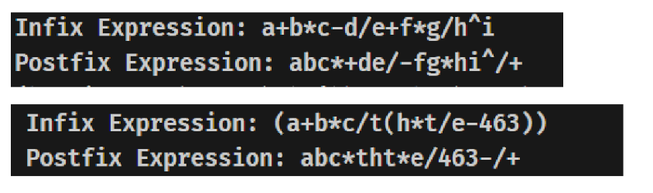

Lab Program 3A:
WAP to simulate the working of a queue of integers using an array. Provide the following operations: Insert, Delete, Display The program should print appropriate messages for queue empty and queue overflow conditions
CODE
#include <stdio.h>
# define N 2
int queue[N];

int front = -1;
int rear = -1;

void enque();
void deque();
void display();
void peek();

int main(void){
int choice = 0;
int i = 1;

while (i == 1){
printf("\n");
printf("\n");
printf("Operations of Queue\n");

printf("1. Enque\n");
printf("2. Deque\n");
printf("3. Peek\n");
printf("4. Display\n");
printf("5. Exit\n");

printf("Choice: ");
scanf("%d", &choice);

switch(choice){
case 1:
enque();
break;
case 2:
deque();
break;
case 3:
peek();
break;
case 4:
display();
break;
case 5:
i = 0;
break;
default:
printf("Invalid Value Entered");
break;
}
}
}

void enque(){

if (rear == N - 1)
printf("Queue Overflow\n");

else if (front == -1 && rear == -1) {
int x = 0;
printf("Element to Enque: ");
scanf("%d", &x);
front = rear = 0;
queue[rear] = x;
}

else {
int x = 0;
printf("Element to Enque: ");
scanf("%d", &x);
rear++;
queue[rear] = x;
}
}

void deque(){
if (front == -1 && rear == -1)
printf("Queue is Empty\n");

else if (front == rear && front != -1){
int element = queue[front];
front = rear = -1;
printf("Element Dequeued: %d", element);
}

else{
int element = queue[front];
front++;
printf("Element Dequeued: %d", element);
}
}

void display(){
if (front == -1 && rear == -1)
printf("Queue is empty\n");

else {
printf("Queue Elements \n");
for (int i = front; i <= rear; i++){
printf("%d. %d\n", i, queue[i]);
}
}
}

void peek(){
if (front == -1 && rear == -1)
printf("Queue is empty\n");

else{
printf("Element at front: %d", queue[front]);
}
}

OUTPUT
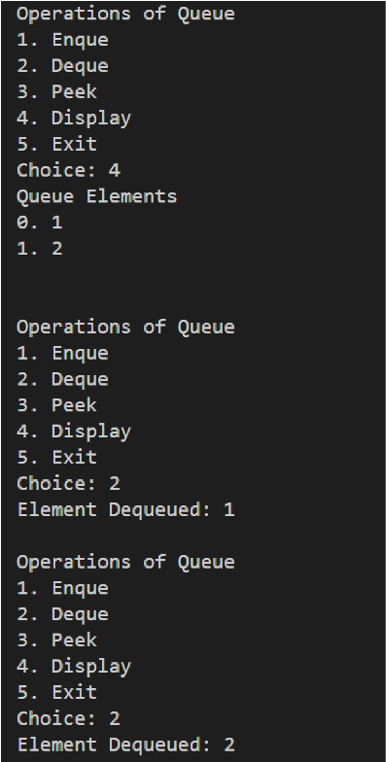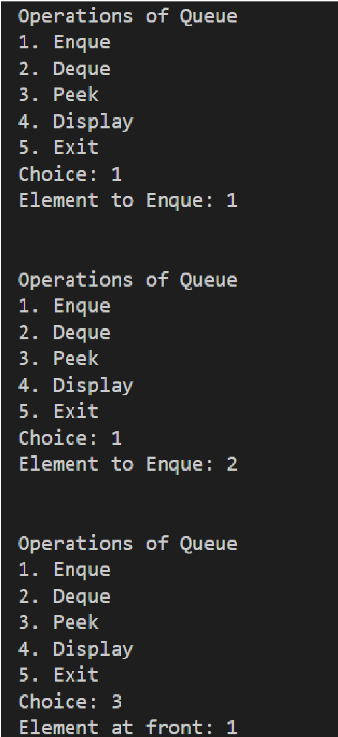

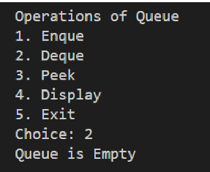

Lab Program 3B:
WAP to simulate the working of a circular queue of integers using an array. Provide the following operations: Insert, Delete & Display The program should print appropriate messages for queue empty and queue overflow conditions
CODE:
#include <stdio.h>
#define N 2
int circular[N];

int front = -1;
int rear = -1;
int e = 0;

void Insert(int x){
if (front == (rear + 1) % N){
printf("Queue is Full\n");
return;
}

if (front == -1 && rear == -1){
front = rear = 0;
circular[rear] = x;
}
else{
rear = (rear + 1) % N;
circular[rear] = x;
}

}

void Delete(){
if (front == -1 && rear == -1){
printf("Queue is Empty\n");
}

else if (front == rear){
int element = circular[front];
front = rear = -1;
printf("Removed Element: %d\n", element);
}

else{
int element = circular[front];
front = (front + 1) % N;
printf("Removed Element %d\n", element);
}
}

void Display(){
printf("THE ELEMENTS OF THE QUEUE ARE\n");
int f = front;
int r = rear;
int count = 1;
if(f != -1 && r!= -1){
while (1){
printf("Position %d: %d\n", count, circular[f]);
if (f == r)
break;

count++;
f = (f+1) % N;
}
}

else{
printf("Queue Empty");
}

}

int main(void){
int i = 1;
while (i == 1){
printf("\n");
printf("Circular Queue Operations: \n");
printf("1. Insert\n");
printf("2. Delete\n");
printf("3. Display\n");
printf("4. Exit\n");

int choice = 0;
printf("Choice: ");
scanf("%d", &choice);

switch(choice){
case 1:
printf("Element to Insert: ");
scanf("%d", &e);
Insert(e);
break;

case 2:
Delete();
break;

case 3:
Display();
break;

case 4:
i = 0;
printf("You have exited the Circular Queue Operations");
break;
}
printf("\n");
}
}

OUTPUT
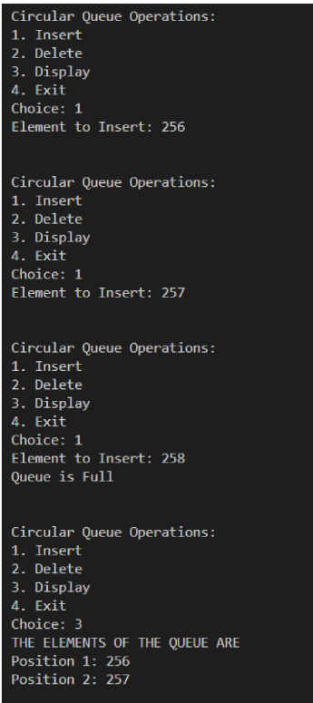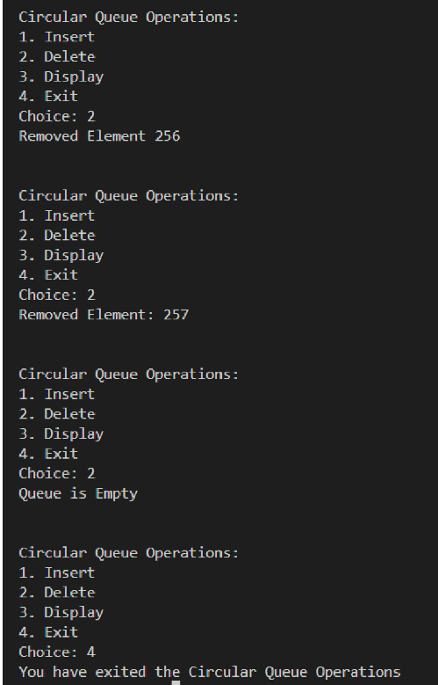

Lab Program 4A:
WAP to Implement Singly Linked List with following operations
a) Create a linked list.
b) Insertion of a node at first position, at any position and at end of list.
c) Display the contents of the linked list.

CODE:
#include <stdio.h>
#include <stdlib.h>

int NODE_count = 0;

typedef struct Node {
int data;
struct Node *next;
} Node;

Node *head = NULL;

//creation of node
Node* create_node(){
Node *newnode = (Node *)malloc(sizeof(Node));

if(newnode == NULL){
printf("Memory allocation failed");
exit(0);
}

int data;
printf("Enter data: ");
scanf("%d", &data);
newnode-> data = data;

newnode-> next = NULL;
return newnode;
}

//inserting node 0-> start, -1-> tail, else-> random position
void insert_node(int pos){
Node *newnode = create_node();

if (pos == 0){//begining
newnode -> next = head;
head = newnode;//head keeps track of the start node
printf("Inserted at start\n");
NODE_count++;
return;
}

if (pos == -1){//end
Node *temp = head;
while (temp-> next != NULL)
temp = temp->next;

temp -> next = newnode;
newnode -> next = NULL;
printf("Inserted node at end\n");
NODE_count++;
return;
}

else{//any pos
Node *temp = head;
int count = 1;
for (int i = 1; i < pos - 1; i++) {
temp = temp->next;
}
newnode-> next = temp-> next;
temp-> next = newnode;
printf("Inserted node at position %d\n", pos);
NODE_count++;

}
}

//display
void display() {
Node *temp = head;
int count = 1;

if (temp == NULL) {
printf("List is empty.\n");
return;
}

while (temp != NULL) {
printf("Position %d: %d\n", count - 1, temp->data);
temp = temp->next;
count++;
}
}

int main(){
int i = 1;
int choice;
int pos;
while(i == 1){
printf("\n\n");
printf("Linked List Operations\n");
printf("1. Insert at begining\n");
printf("2. Insert at end\n");
printf("3. Insert at a position\n");
printf("4. Display\n");
printf("5. Exit\n");

printf("\nChoice: ");
scanf("%d", &choice);

switch(choice){
case 1:
insert_node(0);
break;
case 2:
insert_node(-1);

break;
case 3:{
printf("Enter Position (0 to %d): ", NODE_count + 1);
scanf("%d", &pos);
insert_node(pos);
break;
}
case 4:
display();
break;
case 5:
printf("You exited");
i = 0;
break;
}
}
}
OUTPUT
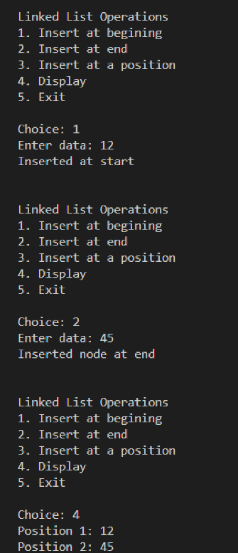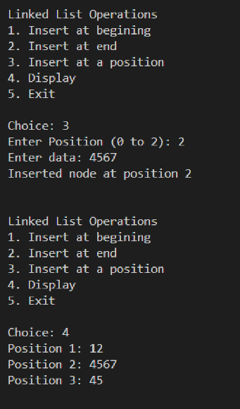

Lab Program 4B:
876. Middle of the Linked List
Given the head of a singly linked list, return the middle node of the linked list.
If there are two middle nodes, return the second middle node.

CODE:
struct ListNode* middleNode(struct ListNode* head) {
struct ListNode* slow = head;
struct ListNode* fast = head;
while (fast != NULL && fast->next != NULL) {
slow = slow->next;
fast = fast->next->next;
}
return slow;
}

Output:


Lab Program 5A:
WAP to Implement Singly Linked List with following operations
a) Create a linked list.
b) Deletion of first element, specified element and last element in the list.
c) Display the contents of the linked list.

CODE:
#include<stdio.h>
#include <stdlib.h>

int node_count = 0;

typedef struct node {
int data;
struct node *next;
} node;

node *head = NULL;

node *create_node(int data) {
node *newnode = (node *)malloc(sizeof(node));
if (newnode == NULL) {
printf("Memory allocation failed");
exit(1);
}

newnode->data = data;
newnode->next = NULL;

if (head == NULL)
head = newnode;

return newnode;
}

int insert_node(int data, int pos) {
node *newnode = create_node(data);
if (pos == 1) {
newnode->next = head;
head = newnode;
printf("Inserted %d at position %d\n", data, pos);
node_count++;
return 0;
}

if (pos == -1) {
node *temp = head;

while (temp->next != NULL)
temp = temp->next;

temp->next = newnode;
newnode->next = NULL;

printf("Inserted %d at end\n", data);
node_count++;
return 0;
}

if (pos > 1 && pos <= node_count + 1) {
int count = 1;
node *temp = head;

while (temp != NULL && count < pos - 1) {
temp = temp->next;
count++;
}

newnode->next = temp->next;
temp->next = newnode;
printf("Inserted %d at position %d\n", data, pos);
node_count++;
return 0;
}

else {
printf("Invalid position\n");
return -1;
}
}

void display() {
int count = 1;
node *temp = head;

if (head != NULL) {
while (temp != NULL) {
printf("P%d: %d\n", count, temp->data);
temp = temp->next;
count++;
}
} else {
printf("Linked List is empty\n");
}
}

int delete(int pos) {
if (pos == 1) {
node *temp = head;
head = head->next;
printf("Element at START has been deleted. It was %d\n", temp->data);
node_count--;
free(temp);
return 0;
}

if (pos == -1) {
node *temp = head;
node *prev = NULL;

while (temp->next != NULL) {
prev = temp;
temp = temp->next;
}

if (prev != NULL)
prev->next = NULL;

printf("Element at END has been deleted. It was %d\n", temp->data);
node_count--;
free(temp);
return 0;
}

if (pos > 1 && pos <= node_count) {
int count = 1;
node *prev = head;
node *temp = head;
while (temp != NULL && count < pos) {
count++;
prev = temp;
temp = temp->next;
}

prev->next = temp->next;
printf("Element at P%d has been deleted. It was %d\n", pos, temp->data);
node_count--;
free(temp);
return 0;
}
return -1;
}

void display_options() {
int choice;
while(1) {
printf("\n1. Insert Node\n");
printf("2. Delete Node\n");
printf("3. Display Linked List\n");
printf("4. Exit\n");
printf("Enter choice: ");
scanf("%d", &choice);

switch(choice) {
case 1: {
int data, pos;
printf("Enter data to insert: ");
scanf("%d", &data);
printf("Enter Position: ");
scanf("%d", &pos);

if (pos > node_count + 1 || pos < 1) {
printf("Node cannot be inserted at position %d\n", pos);
} else {
insert_node(data, pos);
}
break;
}
case 2: {
if (node_count == 0) {
printf("There are no elements in the list to delete\n");
} else {
printf("1. Delete at start\n");
printf("2. Delete at end\n");
printf("3. Delete at position\n");
int delete_choice;
scanf("%d", &delete_choice);
switch(delete_choice) {
case 1:
delete(1);
break;
case 2:
delete(-1);
break;
case 3: {
int pos;
printf("Enter position: ");
scanf("%d", &pos);
if (pos <= node_count && pos > 0) {
delete(pos);
} else {
printf("Invalid position\n");
}
break;
}
default:
printf("Invalid choice\n");
break;
}
}
break;
}
case 3:
display();
break;
case 4:
return;
default:
printf("Invalid choice, try again\n");
break;
}
}
}

int main() {
display_options();
return 0;
}
OUTPUT
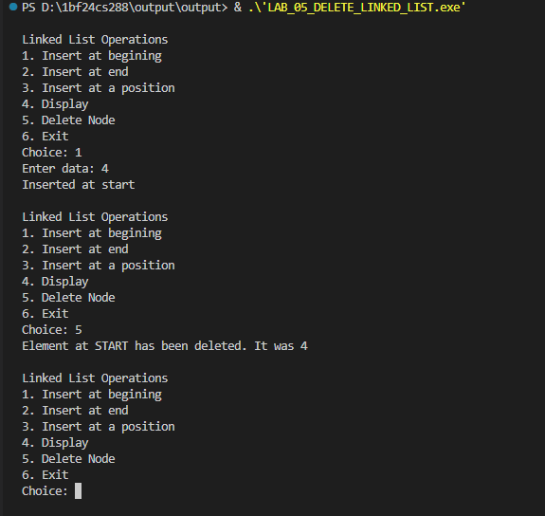

Lab Program 5B
203. Remove Linked List Elements
Given the head of a linked list and an integer val, remove all the nodes of the linked list that has Node.val == val, and return the new head.
CODE:
struct ListNode* removeElements(struct ListNode* head, int val) {
struct ListNode* dummy = (struct ListNode*)malloc(sizeof(struct ListNode));
if (dummy == NULL) {
return head;
}

dummy->val = 0;
dummy->next = head;
struct ListNode* current = dummy;

while (current->next != NULL) {

if (current->next->val == val) {

struct ListNode* node_to_delete = current->next;
current->next = current->next->next;
free(node_to_delete);

} else {
current = current->next;
}
}

struct ListNode* new_head = dummy->next;
free(dummy);

return new_head;
}

OUTPUT:
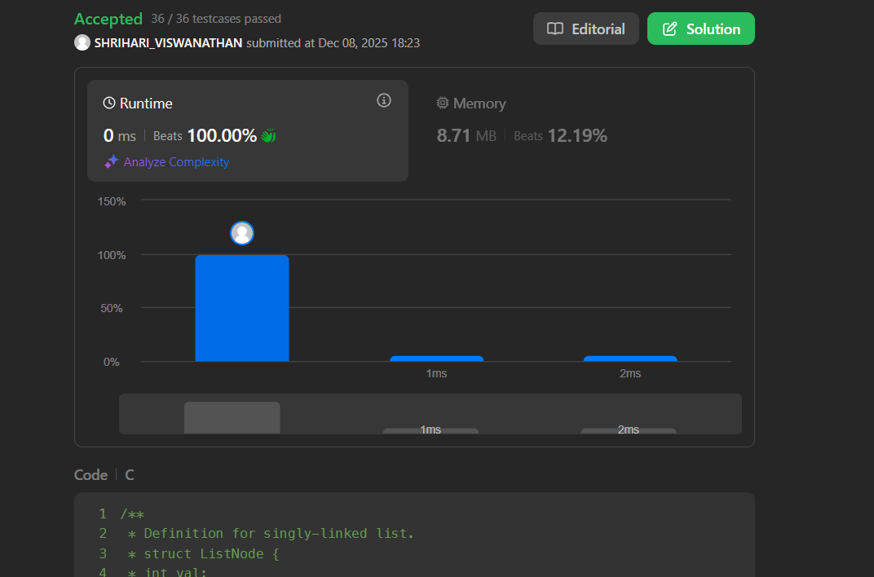

Lab Program 6A:
WAP to Implement Single Link List with following operations: Sort the linked list, Reverse the linked list, Concatenation of two linked lists.
CODE:
#include <stdio.h>
#include <stdlib.h>

int node_count = 0;

typedef struct node {
int data;
struct node *next;
} node;

node *head = NULL; // Global head for the linked list

// Function to display the linked list
void display() {
int count = 1;
node *temp = head;

if (head != NULL) {
while (temp != NULL) {
printf("P%d: %d\n", count, temp->data);
temp = temp->next;
count++;
}
} else {
printf("Linked List is empty\n");
}
}

// Create a new node
node *create_node(int data) {
node *newnode = (node *)malloc(sizeof(node));
if (newnode == NULL) {
printf("Memory allocation failed\n");
exit(1);
}
newnode->data = data;
newnode->next = NULL;
return newnode;
}

// Insert at the start of the list
void insert_at_start(int data) {
node *newnode = create_node(data);
newnode->next = head;
head = newnode;
node_count++;
printf("Inserted %d at the start\n", data);
}

// Insert at the end of the list
void insert_at_end(int data) {
node *newnode = create_node(data);
if (head == NULL) {
head = newnode;
} else {
node *temp = head;
while (temp->next != NULL) {
temp = temp->next;
}
temp->next = newnode;
}
node_count++;
printf("Inserted %d at the end\n", data);
}

// Insert at a specific position in the list
void insert_at_position(int data, int pos) {
if (pos < 1 || pos > node_count + 1) {
printf("Invalid position\n");
return;
}

node *newnode = create_node(data);
if (pos == 1) {
newnode->next = head;
head = newnode;
} else {
node *temp = head;
for (int i = 1; i < pos - 1; i++) {
temp = temp->next;
}
newnode->next = temp->next;
temp->next = newnode;
}
node_count++;
printf("Inserted %d at position %d\n", data, pos);
}

// Delete at the start of the list
void delete_at_start() {
if (head == NULL) {
printf("List is empty, nothing to delete\n");
return;
}

node *temp = head;
head = head->next;
printf("Deleted element at start: %d\n", temp->data);
free(temp);
node_count--;
}

// Delete at the end of the list
void delete_at_end() {
if (head == NULL) {
printf("List is empty, nothing to delete\n");
return;
}

if (head->next == NULL) { // Only one element in the list
free(head);
head = NULL;
} else {
node *temp = head;
while (temp->next && temp->next->next) {
temp = temp->next;
}
free(temp->next);
temp->next = NULL;
}
node_count--;
printf("Deleted element at end\n");
}

// Delete at a specific position in the list
void delete_at_position(int pos) {
if (pos < 1 || pos > node_count) {
printf("Invalid position\n");
return;
}

if (pos == 1) {
delete_at_start();
} else {
node *temp = head;
for (int i = 1; i < pos - 1; i++) {
temp = temp->next;
}
node *del_node = temp->next;
temp->next = del_node->next;
printf("Deleted element at position %d: %d\n", pos, del_node->data);
free(del_node);
node_count--;
}
}

// Sort the list using Bubble Sort
void bubble_sort() {
if (head == NULL || head->next == NULL) {
printf("List is too small to sort\n");
return;
}

node *i, *j;
int temp;
for (i = head; i != NULL; i = i->next) {
for (j = i->next; j != NULL; j = j->next) {
if (i->data > j->data) {
temp = i->data;
i->data = j->data;
j->data = temp;
}
}
}
printf("List sorted using Bubble Sort\n");
display();
}

// Reverse the list using pointer changes
void reverse() {
node *prev = NULL;
node *current = head;
node *next = NULL;

while (current != NULL) {
next = current->next;
current->next = prev;
prev = current;
current = next;
}
head = prev;
printf("List reversed\n");
display();
}

// Concatenate two linked lists
void concatenate(node *list2) {
if (head == NULL) {
head = list2;
} else {
node *temp = head;
while (temp->next != NULL) {
temp = temp->next;
}
temp->next = list2;
}
printf("Lists concatenated\n");
}

// Function to input data for a new linked list
node *input_linked_list(node *head) {
int data, more;
node *temp;
do {
printf("Enter data for new node: ");
scanf("%d", &data);
node *newnode = create_node(data);
if (head == NULL) {
head = newnode;
} else {
temp = head;
while (temp->next != NULL) {
temp = temp->next;
}
temp->next = newnode;
}
node_count++;
printf("Do you want to add another node? (1 = Yes, 0 = No): ");
scanf("%d", &more);
} while (more == 1);
return head;
}

// Display menu and handle user input
void menu() {
int choice;
do {
printf("\nMenu:\n");
printf("1. Insert at Start\n");
printf("2. Insert at End\n");
printf("3. Insert at Position\n");
printf("4. Delete at Start\n");
printf("5. Delete at End\n");
printf("6. Delete at Position\n");
printf("7. Display List\n");
printf("8. Sort List\n");
printf("9. Reverse List\n");
printf("10. Concatenate Lists\n");
printf("11. Exit\n");
printf("Enter choice: ");
scanf("%d", &choice);

int data, pos;
node *list2 = NULL;

switch(choice) {
case 1:
printf("Enter data: ");
scanf("%d", &data);
insert_at_start(data);
break;
case 2:
printf("Enter data: ");
scanf("%d", &data);
insert_at_end(data);
break;
case 3:
printf("Enter data and position: ");
scanf("%d %d", &data, &pos);
insert_at_position(data, pos);
break;
case 4:
delete_at_start();
break;
case 5:
delete_at_end();
break;
case 6:
printf("Enter position: ");
scanf("%d", &pos);
delete_at_position(pos);
break;
case 7:
display();
break;
case 8:
bubble_sort();
break;
case 9:
reverse();
break;
case 10:
printf("Concatenating with another list\n");
list2 = input_linked_list(list2); // Input for second list to concatenate
concatenate(list2);
break;
case 11:
printf("Exiting program...\n");
break;
default:
printf("Invalid choice\n");
}
} while (choice != 11);
}

int main() {
menu();
return 0;
}

OUTPUT
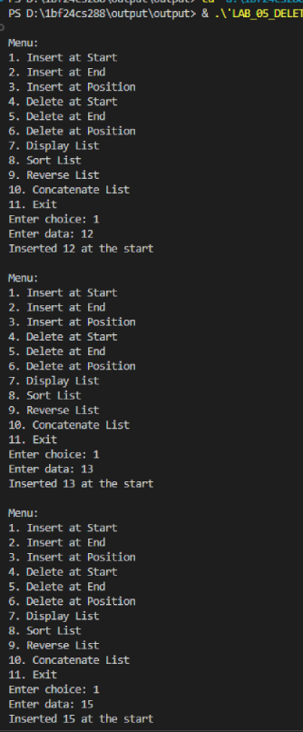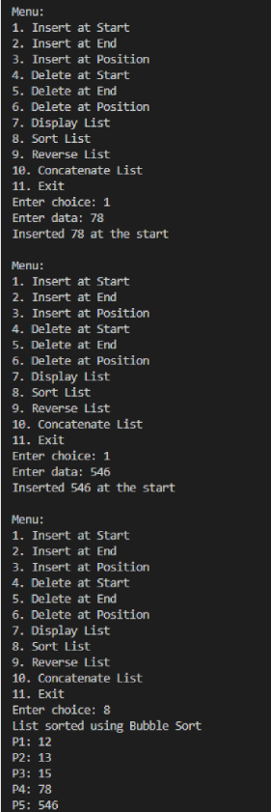

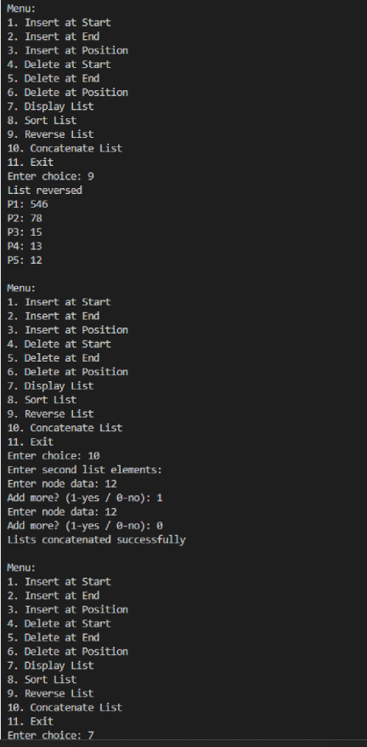
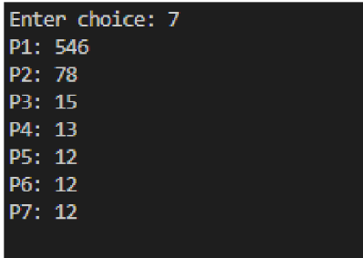
Lab Program 6B:
WAP to Implement Single Link List to simulate Stack & Queue Operations.
CODE:
- STACK
#include <stdio.h>
#include <stdlib.h>
struct node
{
int data;
struct node *next;
};
struct node* top=NULL;
void push(int w){
struct node* newnode=(struct node*)malloc(sizeof(struct node));
newnode->data=w;
newnode->next=top;
top=newnode;
}
void pop(){
if(top==NULL){
printf("STACK UNDERFLOW\n");
return;
}
struct node* temp=top;
top=top->next;
printf("The popped element is: %d\n",temp->data);
free(temp);
}
void display(){
struct node* temp=top;
if(temp==NULL){
printf("STACK IS EMPTY\n");
return;
}
printf("The elements in the stack are:\n");
while(temp!=NULL){
printf("%d\n",temp->data);
temp=temp->next;
}
}
int main(){
int choice, value;
while(1){
printf("\nEnter the operation\n1: Push\n2: Pop\n3: Display\n4: Exit\n");
scanf("%d",&choice);
switch(choice){
case 1:
printf("Enter the value to push: ");
scanf("%d",&value);
push(value);
break;
case 2:
pop();
break;
case 3:
display();
break;
case 4:
exit(0);
default:
printf("INVALID CHOICE\n");
}
}
return 0;
}
OUTPUT
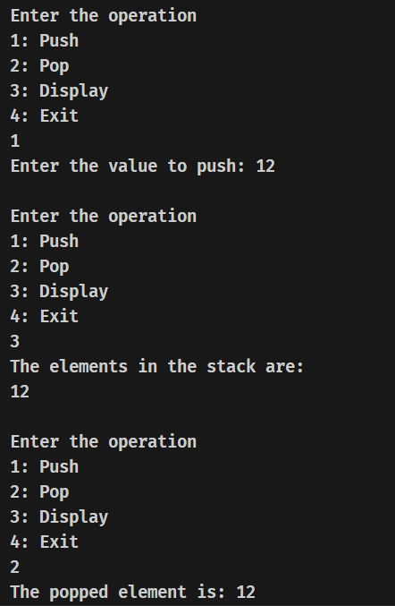
- QUEUE
#include <stdio.h>
#include <stdlib.h>
struct node
{
int data;
struct node *next;
};
struct node* front=NULL;
struct node* rear=NULL;
void enqueue(int w){
struct node* newnode=(struct node*)malloc(sizeof(struct node));
newnode->data=w;
newnode->next=NULL;
if(rear==NULL){
front=rear=newnode;
return;
}
rear->next=newnode;
rear=newnode;
}
void dequeue(){
if(front==NULL){
printf("QUEUE UNDERFLOW\n");
return;
}
struct node* temp=front;
front=front->next;
if(front==NULL){
rear=NULL;
}
printf("The dequeued element is: %d\n",temp->data);
free(temp);
}
void display(){
struct node* temp=front;
if(temp==NULL){
printf("QUEUE IS EMPTY\n");
return;
}
printf("The elements in the queue are:\n");
while(temp!=NULL){
printf("%d\n",temp->data);
temp=temp->next;
}
}
int main(){
int choice, value;
while(1){
printf("\nEnter the operation\n1: Enqueue\n2: Dequeue\n3: Display\n4: Exit\n ");
scanf("%d",&choice);
switch(choice){
case 1:
printf("Enter the value to enqueue: ");
scanf("%d",&value);
enqueue(value);
break;
case 2:
dequeue();
break;
case 3:
display();
break;
case 4:
exit(0);
default:
printf("INVALID CHOICE\n");
}
}
return 0;
}

OUTPUT
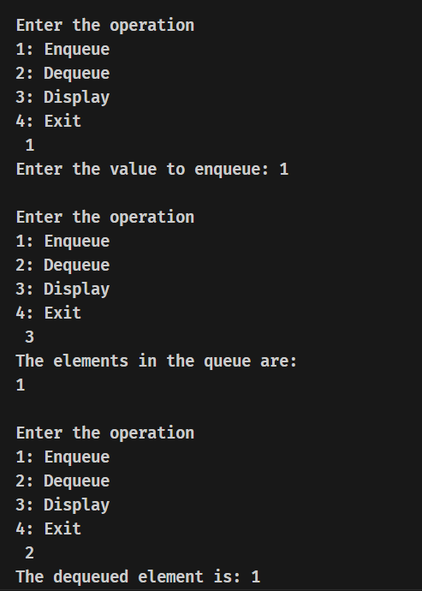

Lab Program 7A:
WAP to Implement doubly link list with primitive operations
a) Create a doubly linked list.
b) Insert a new node to the left of the node.
c) Delete the node based on a specific value
d) Display the contents of the list

CODE:
#include <stdio.h>
#include <stdlib.h>
struct node
{
int data;
struct node *next;
struct node *prev;
};
struct node *head = NULL;
struct node *tail = NULL;
void creation(int m)
{
if (m < 0)
{
printf("INVALID INPUT\n");
return;
}
int a;
struct node *newnode;
for (int i = 0; i < m; i++)
{
newnode = (struct node *)malloc(sizeof(struct node));
printf("Enter the data: ");
scanf("%d", &a);
newnode->data = a;
newnode->next = NULL;
newnode->prev = NULL;
if (head == NULL)
{
head = newnode;
}
else
{
tail->next = newnode;
newnode->prev = tail;
}
tail = newnode;
}
}
void insert_at_begining(int x)
{
struct node *newnode;
newnode = (struct node *)malloc(sizeof(struct node));
newnode->next = NULL;
newnode->prev = NULL;
newnode->data = x;
if (head == NULL)
{
head = newnode;
tail = newnode;
}
else
{
newnode->next = head;
head->prev = newnode;
head = newnode;
}
}
void insert_at_end(int x)
{
struct node *newnode;
newnode = (struct node *)malloc(sizeof(struct node));
newnode->next = NULL;
newnode->prev = NULL;
newnode->data = x;
if (head == NULL)
{
head = newnode;
tail = newnode;
}
else
{
newnode->prev = tail;
tail->next = newnode;
tail = newnode;
}
}
void delete_by_value(int p)
{
struct node *temp = head;
if (head == NULL)
{
printf("LIST IS EMPTY\n");
return;
}
for (int i = 1; temp->data != p && temp != NULL; i++)
{
temp = temp->next;
}
if (temp == NULL)
{
printf("VVALUE NOT FOUND\n");
return;
}
temp->prev->next = temp->next;
temp->next->prev = temp->prev;
printf("DELETED ELEMENT IS %d\n", temp->data);
free(temp);
}
void delete_by_position(int q)
{
struct node *temp = head;
if (head == NULL)
{
printf("LIST IS EMPTY\n");
return;
}
for (int i = 1; i < q && temp != NULL; i++)
{
temp = temp->next;
}
if (temp == NULL)
{
printf("VVALUE NOT FOUND\n");
return;
}
temp->prev->next = temp->next;
temp->next->prev = temp->prev;
printf("DELETED ELEMENT IS %d\n", temp->data);
free(temp);
}
void display()
{
struct node *temp = head;
printf("THE ELEMENTS OF LIST ARE: \n");
while (temp != NULL)
{
printf("%d\n", temp->data);
temp = temp->next;
}
}
int main()
{
int n, ch, val;
while (1)
{
printf("\nENTER THE OPERATION TO BE PERFORMED:\n1.CREATE DOUBLY LINKED LIST\n2.INSERT AT BEGINING\n3.INSERT AT END\n4.DELETE BY VALUE\n5.DISPLAY\n6.DELETE BY POSITION\n7.EXIT\n");
scanf("%d", &ch);
switch (ch)
{
case 1:
printf("ENTER THE NUMBER OF NODES TO BE CREATED: ");
scanf("%d", &n);
creation(n);
break;
case 2:
printf("ENTER THE VALUE TO BE INSERTED AT BEGINING: ");
scanf("%d", &val);
insert_at_begining(val);
break;
case 3:
printf("ENTER THE VALUE TO BE INSERTED AT END: ");
scanf("%d", &val);
insert_at_end(val);
break;
case 4:
printf("ENTER THE VALUE TO BE DELETED: ");
scanf("%d", &val);
delete_by_value(val);
break;
case 5:
display();
break;
case 6:
printf("ENTER THE POSITION TO BE DELETED: ");
scanf("%d", &val);
delete_by_position(val);
break;

case 7:
exit(0);

default:
printf("INVALID INPUT\n");
}
}
return 0;
}

OUTPUT
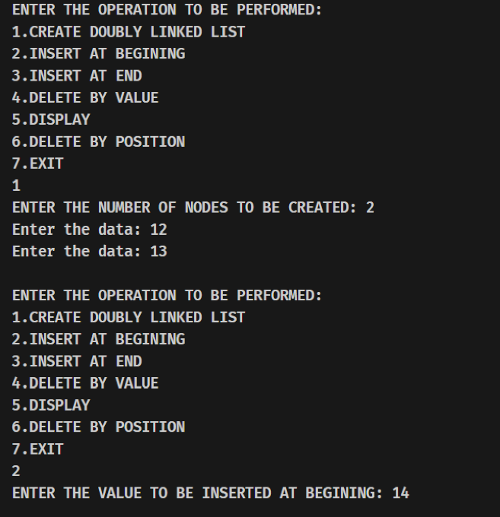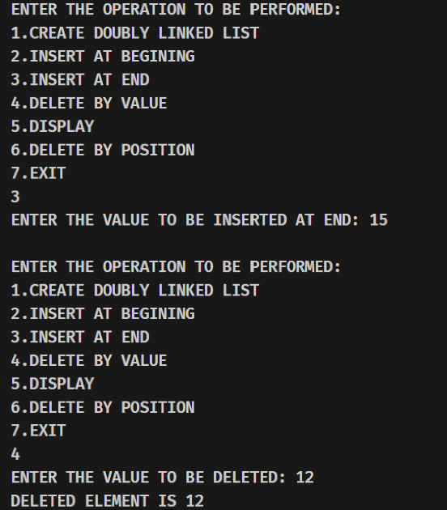
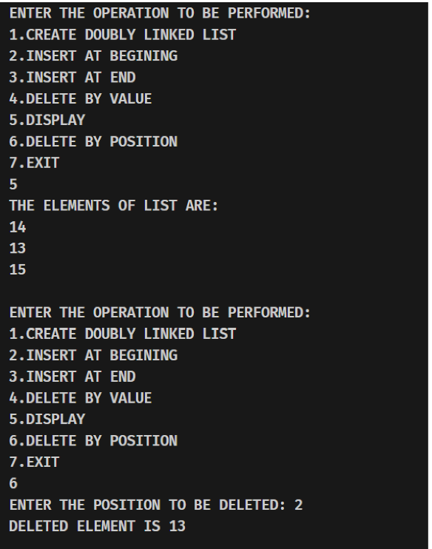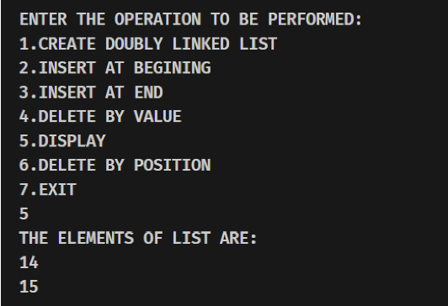

Lab Program 7B
141. Linked List Cycle
Given head, the head of a linked list, determine if the linked list has a cycle in it.
There is a cycle in a linked list if there is some node in the list that can be reached again by continuously following the next pointer. Internally, pos is used to denote the index of the node that tail's next pointer is connected to. Note that pos is not passed as a parameter.
Return true if there is a cycle in the linked list. Otherwise, return false.
CODE:
bool hasCycle(struct ListNode *head) {
if (head == NULL || head->next == NULL) {
return false;
}
struct ListNode *slow = head;
struct ListNode *fast = head;

while (fast != NULL && fast->next != NULL) {

slow = slow->next;
fast = fast->next->next;

if (slow == fast) {
return true;
}
}
return false;
}
Output:
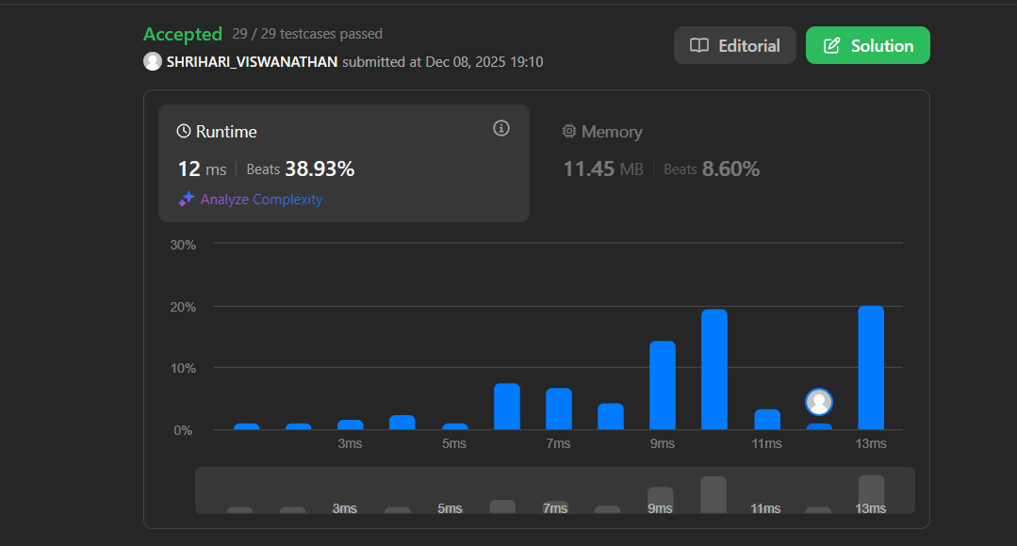

Lab Program 8A
Write a program
a) To construct a binary Search tree.
b) To traverse the tree using all the methods i.e., in-order, preorder and post order
c) To display the elements in the tree.

CODE:
#include<stdio.h>
#include<stdlib.h>
struct node{
int data;
struct node *left;
struct node *right;
};
struct node* create_node(int value){
struct node* newnode = (struct node*)malloc(sizeof(struct node));
newnode->data = value;
newnode->left = NULL;
newnode->right = NULL;
return newnode;
}
struct node* insert(struct node* root, int value){
if(root == NULL){
return create_node(value);
}
if(value < root->data){
root->left = insert(root->left, value);
} else if(value > root->data){
root->right = insert(root->right, value);
}
return root;
}
void inorder(struct node* root){
if(root==NULL){
return;
}
inorder(root->left);
printf("%d ", root->data);
inorder(root->right);
}
void postorder(struct node* root){
if(root==NULL){
return;
}
postorder(root->left);
postorder(root->right);
printf("%d ", root->data);
}
void preorder(struct node* root){
if(root==NULL){
return;
}
printf("%d ", root->data);
preorder(root->left);
preorder(root->right);
}
void display(struct node* root ){
printf("BST ELEMENTS (INORDER): ");
inorder(root);
printf("\n");
}
int main(){
struct node* root = NULL;
int choice, value;
while(1){
printf("\n----- BINARY SEARCH TREE OPERATIONS -----\n");
printf("1. Insert\n");
printf("2. Inorder Traversal\n");
printf("3. Preorder Traversal\n");
printf("4. Postorder Traversal\n");

printf("5. Display BST\n");
printf("6. Exit\n");
printf("Enter your choice: ");
scanf("%d", &choice);
switch(choice){
case 1:
printf("Enter value to insert: ");
scanf("%d", &value);
root = insert(root, value);
break;
case 2:
printf("Inorder Traversal: ");
inorder(root);
printf("\n");
break;
case 3:
printf("Preorder Traversal: ");
preorder(root);
printf("\n");
break;
case 4:
printf("Postorder Traversal: ");
postorder(root);
printf("\n");
break;
case 5:
display(root);
break;
case 6:
exit(0);
default:
printf("INVALID INPUT\n");
}
}
return 0;
}

OUTPUT
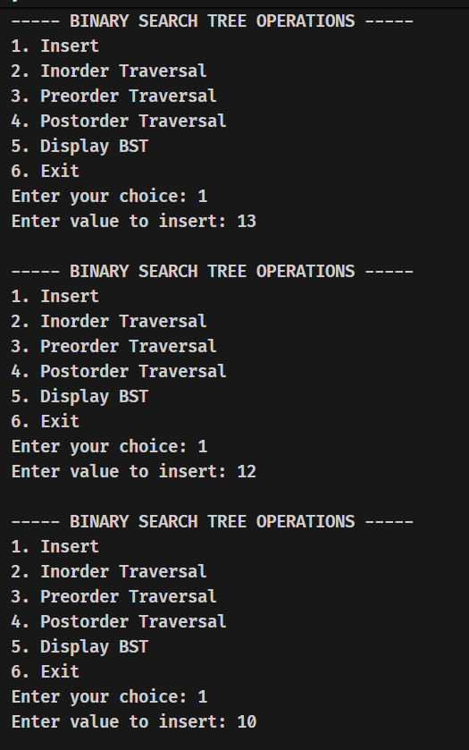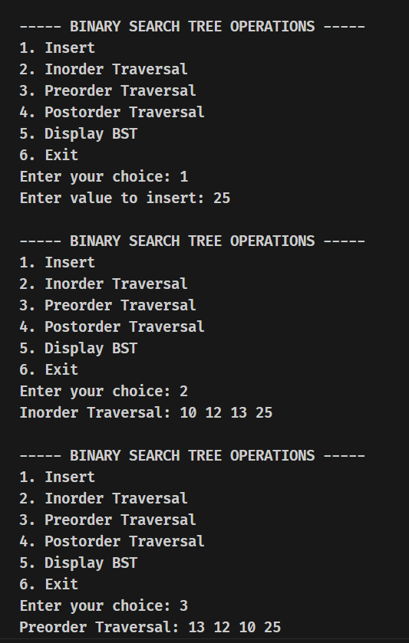

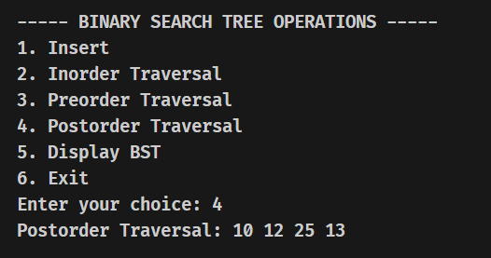

Lab Program 8B
617. Merge Two Binary Trees
You are given two binary trees, root1 and root2.
Imagine placing one tree over the other such that some nodes from the two trees overlap while others do not. You need to merge the two trees into a new binary tree. The merging rule is as follows:
If two nodes overlap (i.e., they are both non-null), sum their values and use the result as the value of the merged node.
If one of the nodes is null, use the non-null node as the node in the new tree.
You need to return the merged tree.
Note: The merging process should start from the root nodes of both trees.

CODE:
struct TreeNode* mergeTrees(struct TreeNode* root1, struct TreeNode* root2) {
// If one of the nodes is NULL, return the other one.
if (!root1) return root2;
if (!root2) return root1;

// Merge the values of the nodes
root1->val += root2->val;

// Recursively merge the left and right subtrees
root1->left = mergeTrees(root1->left, root2->left);
root1->right = mergeTrees(root1->right, root2->right);

return root1;
}
Output:
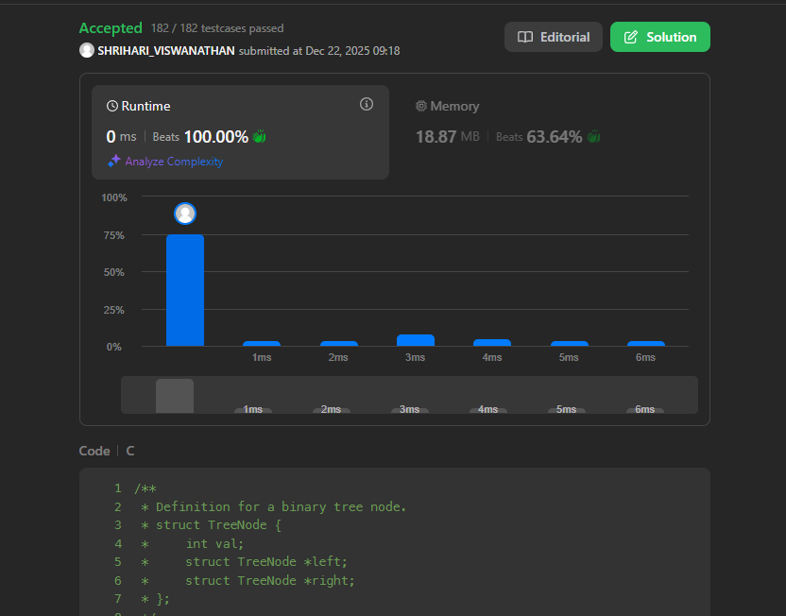

Lab Program 9A
Write a program to traverse a graph using BFS method.
CODE:
#include <stdio.h>

int n;
int graph[10][10];
int visited[10];
int queue[10], front = 0, rear = -1;

void bfs(int start) {
int i;
visited[start] = 1;
queue[++rear] = start;

while (front <= rear) {
int current = queue[front++]; // Get the front of the queue
printf("%d ", current);

for (i = 0; i < n; i++) {
if (graph[current][i] == 1 && visited[i] == 0) {
visited[i] = 1;
queue[++rear] = i; // Enqueue the vertex
}
}
}
}

int main() {
int i, j, start;

printf("Enter number of vertices: ");
scanf("%d", &n);

printf("Enter adjacency matrix:\n");
for (i = 0; i < n; i++) {
for (j = 0; j < n; j++) {
scanf("%d", &graph[i][j]);
}
}

// Initialize visited array to 0 (unvisited)
for (i = 0; i < n; i++) {
visited[i] = 0;
}

printf("Enter starting vertex: ");
scanf("%d", &start);

printf("BFS Traversal: ");
bfs(start); // Perform BFS traversal starting from 'start' vertex

return 0;
}

Output:
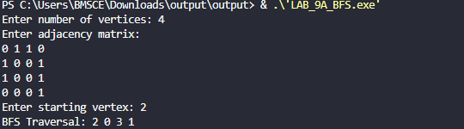

Lab Program 9B:
Write a program to check whether given graph is connected or not using DFS method.
CODE:
#include <stdio.h>

int n;
int graph[10][10];
int visited[10];

void dfs(int v) {
int i;
visited[v] = 1;

for (i = 0; i < n; i++) {
if (graph[v][i] == 1 && visited[i] == 0) {
dfs(i);
}
}
}

int main() {
int i, j;

printf("Enter number of vertices: ");
scanf("%d", &n);

printf("Enter adjacency matrix:\n");
for (i = 0; i < n; i++) {
for (j = 0; j < n; j++) {
scanf("%d", &graph[i][j]);
}
}

for (i = 0; i < n; i++)
visited[i] = 0;

dfs(0); // Start DFS from vertex 0

for (i = 0; i < n; i++) {
if (visited[i] == 0) {
printf("Graph is NOT Connected\n");
return 0;
}
}

printf("Graph is Connected\n");
return 0;
}

Output:
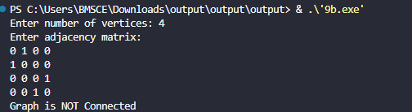

Lab Program 10:
Given a File of N employee records with a set K of Keys(4- digit) which uniquely determine the records in file F.
Assume that file F is maintained in memory by a Hash Table (HT) of m memory locations with L as the set of memory addresses (2-digit) of locations in HT.
Let the keys in K and addresses in L are integers.
Design and develop a Program in C that uses Hash function H: K -> L as H(K)=K mod m (remainder method), and implement hashing technique to map a given key K to the address space L.
Resolve the collision (if any) using linear probing.

CODE:
#include <stdio.h>
#include <stdlib.h>

#define MAX 100

struct Employee {
int key; // 4-digit employee key
int used; // 0 = empty, 1 = occupied
};

struct Employee HT[MAX];
int m;

/* Hash Function */
int hash(int key) {
return key % m;
}

/* Insert using Linear Probing */
void insert(int key) {
int index = hash(key);
int start = index;

while (HT[index].used == 1) {
index = (index + 1) % m;

if (index == start) {
printf("Hash Table is Full! Cannot insert %d\n", key);
return;
}
}

HT[index].key = key;
HT[index].used = 1;
printf("Inserted key %d at address %d\n", key, index);
}

/* Display Hash Table */
void display() {
printf("\nHash Table Contents:\n");
printf("Address\tKey\n");

for (int i = 0; i < m; i++) {
if (HT[i].used)
printf("%d\t%d\n", i, HT[i].key);
else
printf("%d\t--\n", i);
}
}

int main() {
int n, key;

printf("Enter number of memory locations (m): ");
scanf("%d", &m);

// Initialize hash table
for (int i = 0; i < m; i++) {
HT[i].used = 0;
}

printf("Enter number of employee records: ");
scanf("%d", &n);

for (int i = 0; i < n; i++) {
printf("Enter 4-digit employee key: ");
scanf("%d", &key);
insert(key);
}

display();
return 0;
}

Output:
